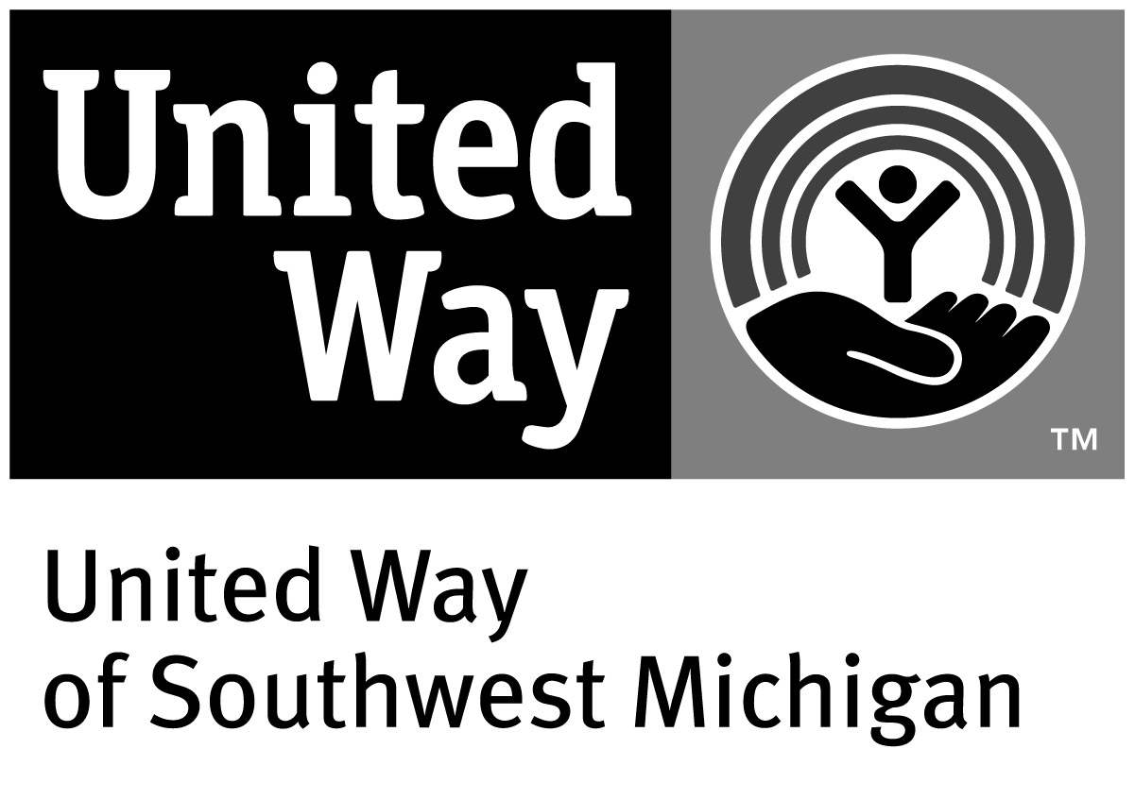
Letter of Intent
2022-2025 UWSM Funding Cycle

If you need any accommodations to complete the application process, please contact Sara Barlow via email at sara.barlow@uwsm.org or by phone at 269-982-4029.

If you have any questions, please email impact@uwsm.org.

Organizations that want to seek funding from United Way of Southwest Michigan for the
2022-2025 funding cycle MUST submit a Letter of Intent prior to completing the application. A Letter of Intent MUST be completed for EVERY program or project applying for funding.

Letters of Intent must include the following:

Basic Qualifications:
- Do you serve Berrien, Cass and/or Van Buren County residents?
☐Yes
☐ No

- Are you tax exempt?
☐Yes
☐ No
If no, please explain.

- Do you have a Board of Directors or advisory group?
☐Yes
☐ No
If no, please explain.

Agency Information:
- Agency Name
- Executive Director
- Contact Email
- Contact Phone
- Website
- Tell us about your organization, including, but not limited to your mission statement.

- Are you willing to create/actively implement an equity statement?
☐Yes
☐ No
- The following documents are required for the application. Are you able to provide the following information during the application process?
  - Board roster, with contact information
☐Yes
☐ No
  - Proof of tax-exempt status
☐Yes
☐ No
  - Solicitation Registration (current or letter of exemption)
☐Yes
☐ No
  - Annual operating budget (for the entire organization)
☐Yes
☐ No
  - Audit or financial review
☐Yes
☐ No
  - Strategic plan (see examples at www.uwsm.org/agenda)
☐Yes
☐ No
If you are unable to provide one of the following, please explain why.

Program/Project Information:
- Program/Project Name
- Primary Contact
- Primary Contact Phone Number
- Primary Contact Email Address
- Will you be seeking funding through Change Lives or Build Strong Communities?
- Which primary issue will your program/project address (choose only one):
☐ Early Education & Literacy
☐ Post-Secondary Success
☐ Financial Security
☐ Employment
☐ Healthy Bodies
☐ Healthy Minds
☐ Food Security
☐ Safe Environment
- Program/Project Description
  - Describe the program/project that you want to seek funding for.
  - How is it delivered?
  - How does it align with the issues listed in the Community Impact Agenda for Change?
  - What outcomes/outputs/indicators will you measure, and how will you measure them?
  - Please select at least one of the following that your program/project will address.
☐ Increase diversity and inclusion
☐ Reduce inequities
☐ Better access and improvements to community resources & infrastructure
☐ Increase community cohesion
☐ Increase community involvement and participation
☐ Enhance safety
☐ Improve communication and networking between leaders and organizations
☐ Increase access to activities and recreational opportunities
- Proposed Funding Request
  - What amount of funding you plan to ask for annually?
  - What is your rationale or justification for this amount?
- List of Funding Sources
  - How is the program/project currently funded?
  - How do you plan to financially support it in the future?
- Service Scope
  - Approximately how many unduplicated people will you serve each year?
  - What geographic area(s) will this request cover?

Letters of Intent are due NO LATER than 5:00 pm on September 24, 2021. No late submissions will be accepted.

Letters of Intent MUST be submitted electronically to impact@uwsm.org. You will receive a confirmation once the Letter of Intent is received.

Decisions for those that will move forward in the process will be emailed no later than October 29, 2021.

